SUBMISSION TYPE

Poster

TITLE

Development of an Intended Bifactor Engagement Measure

ABSTRACT

Engagement remains a valued employee attitude despite continued disagreement regarding its internal structure and nomological relationship to other constructs. We describe the development of a measure of engagement wherein we *intentionally* pursue a bifactor structure. Furthermore, we follow two scale definition procedures to arrive at our desired bifactor structure: one based on internal consistency and the other informed by CFA modification indices. Ultimately, we arrive at an 18-item scale definition that can be aggregated to two scale definitions based on application.

WORD COUNT

2734

The term “engagement” first emerged in the organizational psychology and business literature in the early 1990s (Kahn, 1990). The evolution of the construct can perhaps be viewed through the lens of semi-distinct lines of research utilizing semantic labels of: 1) work engagement, 2) personal engagement, 4) employee engagement, and 4) burnout. These perspectives carry slightly differing definitions (and subsequently measures), and perhaps contribute to some confusion regarding what exactly is being measured when organizations survey their employees to assess “engagement.” Although “personal engagement” was coined by Kahn (1990), few subsequent articles reference engagement by this name. Schaufeli (2013) distinguishes work engagement from employee engagement on the basis of the referent: “Work engagement refers to the relationship of the employee with his or her *work*, whereas employee engagement may also include the relationship with the *organization*”.

The current project is most closely aligned with the *work engagement* tradition, whose most frequently-cited definition of engagement is “the positive, fulfilling, work-related state of mind that is characterized by vigor, dedication, and absorption. Vigor is characterized by high levels of energy and mental resilience while working. Dedication refers to being strongly involved in one’s work and experiencing a sense of significance, enthusiasm, inspiration, pride, and challenge. Absorption is characterized by being fully concentrated and happily engrossed in one’s work, whereby time passes quickly and one has difficulties with detaching oneself from work” (Schaufeli et al 2002; p. 74).

The nomological relationship of engagement to burnout has been the source of no small amount of debate. One school of thought contends that burnout is the opposite of engagement and resides on the antipode of the engagement spectrum, while others argue that engagement is a distinct construct entirely. Some credence is lent to the former claim by the fact that measures of burnout and engagement tend to show moderate negative correlations (Schaufeli & Bakker, 2003). More recently, however, suggests that they are nomologically distinct (Trógolo et al., 2020). We also align our perspective with the assertion that burnout and engagement are related but separable constructs.

## Why engagement?

Even in the presence of disagreement about the definitional conceptualization of engagement, interest in the construct still abounds. This is likely fueled in large part by its relationships with many other desirable workplace constructs. At the employee level, engagement has been found to relate to organizational commitment (Hanaysha, 2016), job satisfaction (Alarcon & Edwards, 2011), and job performance (Rich et al., 2010). Some lines of study also frame engagement as a positive counterpoint to workaholism (Caesens et al., 2014), particularly in an occupational health context (Girardi et al., 2019). Such research testifies not only to the value of engagement as both a predictor and outcome of organizational relevance, but also to the enthusiasm of academics and practitioners for further understanding the role of engagement at work. In light of this, it is all the more important to better understand the structure of this construct to support future research.

## Our Proposed Model of Engagement

Like many other constructs within the psychology literature, our knowledge of engagement has been at least partially informed by its measurement and linkage to other work attitudes and behaviors. There are currently many engagement scales used for either academic or applied purposes (and sometimes both), which all measure engagement at the individual level (e.g., ubiquitous inventory self-report). Four such scales include the Utrecht Work Engagement Scale (UWES; Schaufeli et al., 2002), the ISA engagement scale (Phuangthuean et al., 2018), the Saks (2006; 2019) scale, and May et al. (2004) scale. These scales differ in the number and content of dimensions. For example, the ISA divides engagement into intellectual, social, and affective components, while the Utrecht Work Engagement Scale (UWES) focuses on three dimensions including vigor, dedication, and absorption. However, the UWES has been subject to criticism focused on the three subscales being so highly correlated, it may be argued that a unidimensional structure may be a better structural representation than the three-factor model (Kulikowski, 2017; Willmer et al., 2019). We retain the vigor-dedication-absorption structure put forth in Schaufeli et al. (2002) and also specified in the UWES as the foundation for our construct definition. We believe that some of the inter-construct association may be able to be accounted for when attitudinal components are additionally and simultaneously recognized.

**Engagement as an attitude**. The first definition of “engagement” in a work context was offered by Kahn (1990): “the harnessing of organization members’ selves to their work roles; in engagement, people employ and express themselves physically, cognitively, and emotionally during role performances.” Although this definition was quickly outpaced by ensuing contributors (see, for example, Baumruk [2004] and Shaw [2005], who framed it in terms of one’s cognitive and affective *commitment* to one’s organization), Kahn (1990)‘s definition is notable in that it is inspired by the then-ascendant tripartite model of attitudes. This model is usually attributed to Rosenberg (1960) and proposes that attitudes can be deconstructed into cognitive, affective, and behavioral components (Kaiser & Wilson, 2019). Even though it is not specifically a work engagement model, the tripartite model has helped researchers define and deconstruct attitudes to gain a better understanding of individuals’ reactions towards specific attitude objects (Kaiser and Wilson (2019)).

## Bifactor structures. Bifactor analyses are commonly used in the exploration of common method variance (e.g., Biderman et al., 2011; Gäde et al., 2017; Reise, 2012). Giordano et al. (2020) provide an overview regarding past and potential applications of exploratory bifactor analysis and cite Reise (2012) as an influential impetus for the resurgence of bifactor models in general. Such models have been increasingly adopted in research and application of item response theory (IRT) and structural equation modeling (SEM; Reise, 2012). Bifactor models traditionally assess how the covariance among a set of item responses is accounted for by a single general factor reflecting common variance, compared to a group of factors reflecting common variance among clusters of items. However, for this study, two groups of factors were included in one bifactor model to assess the multidimensionality arising from item responses to measure the general factors from each group (i.e., attitudinal and substantive). The resulting group factors have a direct relationship with each variable observed. In this case, each latent factor from both the substantive and attitudinal models have overlapping effects on each variable.

# Methods

Informed by the Schaufeli et al. (2002) definition, we conceptualize engagement as a mental state wherein employees feel energized, are enthusiastic about the content of their work and the things they do, and are so immersed in their work activities that time seems compressed. Furthermore, we approach our measurement of these engagement domains through the lens of an attitude and generate indicators that are indicative of cognitive, affective, and behavioral attitudinal components. Although by tradition, item complexity has been considered something to avoid, we eagerly embraced this complexity, both for the methodological extension of bifactor approaches as well as the potential to account for inter-domain associations of engagement measures previously viewed as a nuisance (e.g., Kulikowski, 2017).

## Item generation

From our construct definitions, we generated an initial set of 50 candidate items, with the ultimate goal of reducing them to a final set of 18 (two items per bifactor). Each item was sampled from two content domains: one substantive (Vigor, Dedication, or Absorption) and one attitudinal (cognitive, affective, or behavioral). For example, the item “My job makes me feel like I’m part of something meaningful” is intended to reflect the affective component of dedication.

### Content validation and initial item reduction. The 50 candidate items underwent two rounds of content validation and subsequent revision by teams of graduate students and faculty. The first sorting process was conducted by seven masters’ and PhD students in Industrial-Organizational Psychology, with each student provided content domain definitions and instructions to place each item into substantive as well as attitudinal dimensions (i.e., each item was sorted *twice*). Items that were not sorted into the same dimension by at least five of the seven raters were deemed candidates for revision or deletion. The instrument authors reviewed the wording of these items and eliminated 14 that could not be salvaged. Most revisions entailed strengthening the attitudinal component of the item (that is, our content validity exercises exhibited the most rater disagreement along the attitudinal content domains). A final content validation was undertaken by three graduate students and a faculty member who sorted the 36 items into one of nine domains (e.g., Vigor-Affect, Dedication-Behavior, etc.). Any disagreement at this stage was resolved through a final round of minor item editing.

## Participants

330 individuals provided ratings across 36 candidate items. These participants were gathered via snowball sampling, with initial invitations sent primarily to undergraduate and graduate students, as well as professional acquaintances of faculty members. The surveys were administered online via Qualtrics. Participant job title, hours worked per week, and organizational tenure were recorded. Mean hours worked per week was 40.38 (SD = 13.27). Mean organizational tenure was 6.82 years (SD = 8.50).

Participants provided their job titles via an optional free text-entry box at the end of the survey. We classified job titles according to the International Standard Classification of Occupations (ISCO-8) via the *labourR* package (Kouretsis et al., 2020). The ISCO hierarchically organizes jobs in increasing order of specificity. For example, the first level of the hierarchy distinguishes a professional from a clerical worker or a technician. On the second level, professionals are distinguished among each other by whether they are engineers, medical workers, lawyers, and so on. According to this classification, 120 of our participants were professionals, 51 were managers, 4 were clerical support workers, 3 were plant and machine operators, and 1 was a trade worker.

## Scale development “conditions”

In addition to an intentional bifactor structure, we wanted to also introduce procedural conditions regarding the effort to obtain final scale definitions. One team of scale reductionists therefore focused on corrected item-total correlations while the other based final scale definitions on CFA modification indices.

**Corrected item-total correlations.** Using the alpha function from the psych package, we calculated corrected item-total correlations for all items. For each attitudinal-substantive crossing, we removed the item with the lowest corrected item-total correlation from the scale definition, leaving three items per attitudinal-substantive dimension. We then re-ran internal consistency analyses upon our 3-item definitions and repeated this process, leaving only two items per substantive-attitudinal dimension which was our desired scale length (18 items).

**CFA Modification Indices.** In our second scale development approach, we followed two parallel stepwise item reduction processes centered around eliminating items in decreasing magnitude of confirmatory factor analysis (CFA) modification index. Specifying each 36-item substantive and attitudinal model independently, we requested modification indices from each, with the intent of retaining indicators whose fixed shared residual covariances were associated with meaningful specification within the other structural model (indicating better model fit if the paths were freed). Here we prioritized item retention and deletion such that items were notable candidates for retention if: 1) modification indices were high and 2) residual covariances could be accounted for by the other structural specification. Items were candidates for deletion if: 1) modification index was high (relative to others) and 2) error residual was NOT in alignment with the alternative structural specification. This process was repeated until 18 items remained (i.e., 2 items for each of the 9 substantive-attitudinal pairs).

For example, the path with the highest modification index across both 36-item CFAs was between item 2 and item 4, which are both indicators of “Absorption” and “Cognition”. One of these items was therefore considered a likely candidate for deletion, and semantic preference was given to item 4, “I find it difficult to mentally disconnect from work” over item 2. After item 2 was excluded from both scale definitions (substantive and attitudinal), the CFAs were re-run and modification indices re-checked for bi-factor structure optimizing modifications. Table 1 provides a visual representation of how the CFA modification indices informed item retention and deletion decisions.

**Final scale definitions.** Although we retained two different item reduction lenses for the purpose of this SIOP presentation, we did also land upon a final scale definition. This final definition was a compromise between the CFA-derived and corrected item-total correlation-derived definitions. The final choice of item deletion or retention across the two different candidate models was based on author preference for wording/semantics as well as construct domain coverage (considering the possibility of construct deficiency). Item variance was also consulted as a practical consideration, with retention being more likely for the item exhibiting greater response variance.

# Results

We used R (Version 4.0.3; R Core Team, 2021) and the R-packages *apaTables* (Version 2.0.8; Stanley, 2021), *dplyr* (Version 1.0.2; Wickham, François, et al., 2021), *DT* (Version 0.16; Xie et al., 2021), *forcats* (Version 0.5.0; Wickham, 2021a), *ggplot2* (Version 3.3.2; Wickham, 2016), *kableExtra* (Version 1.3.1; Zhu, 2021), *labourR* (Version 1.0.0; Kouretsis et al., 2020), *lavaan* (Version 0.6.8; Rosseel, 2012), *magrittr* (Version 2.0.1; Bache & Wickham, 2020), *papaja* (Version 0.1.0.9997; Aust & Barth, 2020), *purrr* (Version 0.3.4; Henry & Wickham, 2020), *readr* (Version 1.4.0; Wickham & Hester, 2020), *sem* (Version 3.1.11; Fox et al., 2020; Epskamp, 2019), *semPlot* (Version 1.1.2; Epskamp, 2019), *stringr* (Version 1.4.0; Wickham, 2019), *tibble* (Version 3.1.0; Müller & Wickham, 2021), *tidyr* (Version 1.1.2; Wickham, 2021b), and *tidyverse* (Version 1.3.0; Wickham, Averick, et al., 2019) for all analyses.

The competing 18-item scale definitions identified via the two independent item reduction procedures are presented in Table 2. Subjecting these two structures to bifactor constraints was accomplished via full information maximum likelihood estimation, with the corrected item-total definition, somewhat surprisingly, resulting in a better fitting bifactor model ( $χ^{2}$ = 227.89, RMSEA = 0.05, AIC = 14,050.98) than the CFA modification-index derived bifactor solution ( $χ^{2}$ = 247.01, RMSEA = 0.06, AIC = 14,327.76).

## Final scale definitions

As alluded to above, rather than relying exclusively on empirical superiority, final scale definitions were also informed by considerations of content domain coverage, which slightly favored the CFA modification index-informed definition. Our final scale, as well as all 36 candidate items, is presented in Table 3. Final scale $α$’s were 0.66 (Absorption), 0.71 (Dedication), 0.65 (Vigor), 0.59 (Affect), 0.74 (Cognition), and 0.63 (Behavior). Correlations among unit-weighted scale aggregates from the bifactor scale definitions are presented in Table 4, whereas CFA summary statistics for the 18-item substantive scale, 18-item attitudinal scale, and 18-item bifactor solution are presented in Table 5. Figures 1 through three are visual representations of these CFAs.

# Discussion

The purpose of this study was to present the development of an intentional bifactor measure of engagement. To add an additional element of interest regarding the SIOP audience, we furthermore followed two divergent approaches that resulted in slightly different scale definitions. Surprisingly, the approach focusing on facet-level internal consistency maximization resulted in a better fitting CFA than did the approach focusing on CFA fit. Ultimately, differences were reconciled via qualitative consideration of content domain coverage, and the proposed 18-item final solution is a compromise between the two "experimental" models.

In addition to the information provided in this presentation, we have also documented evidence of convergent and discriminant validity of these scales, although the scope of that extends beyond a single SIOP presentation. We have a much larger technical report that documents the information in this paper as well as broader explorations and that technical report is currently published as an open-access document. Our items also intentionally carry no copyright and are freely available to any researcher or practitioner interested in the topic of engagement. We also believe that the unique bifactor structure provides some unique flexibility to potential end-users (for example, substantive dimensions adherence for research applications, attitudinal components for practical organizational diagnosis).

This project makes at least three unique contributions. Firstly, it introduces a novel measure of engagement, developed in English and available for free, that will allow future researchers to probe the tripartite attitudinal structure of the construct while at the same time measuring the more "traditional" structure. Secondly, we deepen our theoretical understanding of engagement. The unit-weighted inter-scale correlations exhibit only moderately high association (in the .6-ish range), which is promising and perhaps provides some support for retention of the 3-facet substantive model, which has been criticized for high observed inter-scale associations. Thirdly, we more generally advance the use of bifactor analysis as an alternative methodology for testing and comparing structural models of constructs that extends beyond investigations of common method variance. We hope that this endeavor encourages other researchers to also extend the bifactor procedure to novel measurement pursuits.

References

Alarcon, G. M., & Edwards, J. M. (2011). The relationship of engagement, job satisfaction and turnover intentions. *Stress and Health*, *27*(3), e294–e298.

Aust, F., & Barth, M. (2020). *papaja: Create APA manuscripts with R Markdown*. <https://github.com/crsh/papaja>

Bache, S. M., & Wickham, H. (2020). *Magrittr: A forward-pipe operator for r*. [https://CRAN.R-project.org/package=magrittr](https://cran.r-project.org/package=magrittr)

Baumruk, R. (2004). *The missing link: The role of employee engagement in business success*. *47*, 48–52.

Biderman, M. D., Nguyen, N. T., Cunningham, C. J., & Ghorbani, N. (2011). The ubiquity of common method variance: The case of the Big Five. *Journal of Research in Personality*, *45*(5), 417-429.

Caesens, G., Stinglhamber, F., & Luypaert, G. (2014). The impact of work engagement and workaholism on well-being: The role of work-related social support. *Career Development International*.

Epskamp, S. (2019). *SemPlot: Path diagrams and visual analysis of various sem packages’ output*. [https://CRAN.R-project.org/package=semPlot](https://cran.r-project.org/package=semPlot)

Fox, J., Nie, Z., & Byrnes, J. (2020). *Sem: Structural equation models*. [https://CRAN.R-project.org/package=sem](https://cran.r-project.org/package=sem)

Gäde, J. C., Schermelleh-Engel, K., & Klein, A. G. (2017). Disentangling the common variance of perfectionistic strivings and perfectionistic concerns: A bifactor model of perfectionism. *Frontiers in psychology*, *8*, 160.

Giordano, C., Ones, D. S., Waller, N. G., & Stanek, K. C. (2020). Exploratory bifactor measurement models in vocational behavior research. *Journal of Vocational Behavior*, *120*, 103430. <https://doi.org/10.1016/j.jvb.2020.103430>

Girardi, D., De Carlo, A., Dal Corso, L., Andreassen, C. S., & Falco, A. (2019). Is workaholism associated with inflammatory response? The moderating role of work engagement. *TPM-Testing, Psychometrics, Methodology in Applied Psychology*.

Hanaysha, J. (2016). Testing the effects of employee engagement, work environment, and organizational learning on organizational commitment. *Procedia-Social and Behavioral Sciences*, *229*, 289–297.

Henry, L., & Wickham, H. (2020). *Purrr: Functional programming tools*. [https://CRAN.R-project.org/package=purrr](https://cran.r-project.org/package=purrr)

Kahn, W. A. (1990). Psychological conditions of personal engagement and disengagement at work. *Academy of Management Journal*, *33*(4), 692–724.

Kaiser, F. G., & Wilson, M. (2019). The Campbell Paradigm as a Behavior-Predictive Reinterpretation of the Classical Tripartite Model of Attitudes. *European Psychologist*, *24*(4), 359–374. <https://doi.org/10.1027/1016-9040/a000364>

Kouretsis, A., Bampouris, A., Morfiris, P., & Papageorgiou, K. (2020). *LabourR: Classify multilingual labour market free-text to standardized hierarchical occupations*. [https://CRAN.R-project.org/package=labourR](https://cran.r-project.org/package=labourR)

Kulikowski, K. (2017a). Do we all agree on how to measure work engagement? Factorial validity of utrecht work engagement scale as a standard measurement tool–a literature review. *International Journal of Occupational Medicine and Environmental Health*, *30*(2), 161–175.

Kulikowski, K. (2017b). Do we all agree on how to measure work engagement? Factorial validity of utrecht work engagement scale as a standard measurement tool - a literature review. *International Journal of Occupational Medicine and Environmental Health*, *30*(2), 161–175. <https://doi.org/10.13075/ijomeh.1896.00947>

Müller, K., & Wickham, H. (2021). *Tibble: Simple data frames*. [https://CRAN.R-project.org/package=tibble](https://cran.r-project.org/package=tibble)

Phuangthuean, P., Kulachai, W., Benchakhan, K., Borriraksuntikul, T., & Homyamyen, P. (2018). Employee engagement: validating the ISA engagement scale. In *Conference of the International Journal of Arts and Sciences* (Vol. 11, No. 1, pp. 99-108).

R Core Team. (2021). *R: A language and environment for statistical computing*. R Foundation for Statistical Computing. [https://www.R-project.org/](https://www.r-project.org/)

Reise, S. P. (2012). The rediscovery of bifactor measurement models. *Multivariate Behavioral Research*, *47*(5), 667–696. <https://doi.org/10.1080/00273171.2012.715555>

Rich, B. L., Lepine, J. A., & Crawford, E. R. (2010). Job engagement: Antecedents and effects on job performance. *Academy of Management Journal*, *53*(3), 617–635.

Rosenberg, M. J. (1960). Cognitive, affective, and behavioral components of attitudes. In *Attitude organization and change*.

Rosseel, Y. (2012). lavaan: An R package for structural equation modeling. *Journal of Statistical Software*, *48*(2), 1–36. <https://www.jstatsoft.org/v48/i02/>

Saks, A. M. (2006). Antecedents and consequences of employee engagement. *Journal of Managerial Psychology*, *21*(7), 600–619.

Saks, A. M. (2019). Antecedents and consequences of employee engagement revisited. *Journal of Organizational Effectiveness: People and Performance*, *6*(1), 19–38.

Schaufeli, W. B. (2013). What is engagement? In *Employee engagement in theory and practice* (pp. 29–49). Routledge.

Schaufeli, W. B., & Bakker, A. B. (2003). Utrecht work engagement scale: Preliminary manual. *Occupational Health Psychology Unit, Utrecht University, Utrecht*, *26*(1), 64–100.

Schaufeli, W. B., Salanova, M., González-Romá, V., & Bakker, A. B. (2002). The measurement of engagement and burnout: A two sample confirmatory factor analytic approach. *Journal of Happiness Studies*, *3*(1), 71–92.

Shaw, K. (2005). An engagement strategy process for communicators. *Strategic Communication Management*, *9*(3), 26.

Stanley, D. (2021). *ApaTables: Create american psychological association (apa) style tables*. [https://CRAN.R-project.org/package=apaTables](https://cran.r-project.org/package=apaTables)

Trógolo, M. A., Morera, L. P., Castellano, E., Spontón, C., & Medrano, L. A. (2020). Work engagement and burnout: Real, redundant, or both? A further examination using a bifactor modelling approach. *European Journal of Work and Organizational Psychology*, *29*(6), 922–937.

Wickham, H. (2016). *Ggplot2: Elegant graphics for data analysis*. Springer-Verlag New York. <https://ggplot2.tidyverse.org>

Wickham, H. (2019). *Stringr: Simple, consistent wrappers for common string operations*. [https://CRAN.R-project.org/package=stringr](https://cran.r-project.org/package=stringr)

Wickham, H. (2021a). *Forcats: Tools for working with categorical variables (factors)*. [https://CRAN.R-project.org/package=forcats](https://cran.r-project.org/package=forcats)

Wickham, H. (2021b). *Tidyr: Tidy messy data*. [https://CRAN.R-project.org/package=tidyr](https://cran.r-project.org/package=tidyr)

Wickham, H., Averick, M., Bryan, J., Chang, W., McGowan, L. D., François, R., Grolemund, G., Hayes, A., Henry, L., Hester, J., Kuhn, M., Pedersen, T. L., Miller, E., Bache, S. M., Müller, K., Ooms, J., Robinson, D., Seidel, D. P., Spinu, V., … Yutani, H. (2019). Welcome to the tidyverse. *Journal of Open Source Software*, *4*(43), 1686. <https://doi.org/10.21105/joss.01686>

Wickham, H., François, R., Henry, L., & Müller, K. (2021). *Dplyr: A grammar of data manipulation*. [https://CRAN.R-project.org/package=dplyr](https://cran.r-project.org/package=dplyr)

Wickham, H., & Hester, J. (2020). *Readr: Read rectangular text data*. [https://CRAN.R-project.org/package=readr](https://cran.r-project.org/package=readr)

Willmer, M., Westerberg Jacobson, J., & Lindberg, M. (2019). Exploratory and confirmatory factor analysis of the 9-item utrecht work engagement scale in a multi-occupational female sample: A cross-sectional study. *Frontiers in Psychology*, *10*. <https://doi.org/10.3389/fpsyg.2019.02771>

Xie, Y., Cheng, J., & Tan, X. (2021). *DT: A wrapper of the javascript library ’datatables’*. [https://CRAN.R-project.org/package=DT](https://cran.r-project.org/package=DT)

Zhu, H. (2021). *KableExtra: Construct a complex table with ’kable’ and pipe syntax*. [https://CRAN.R-project.org/package=kableExtra](https://cran.r-project.org/package=kableExtra)

**Table 1**

**Attitudinal structure modification indices (36 item analysis)**

|  |  |  |  |
| --- | --- | --- | --- |
| Element 1 | Element 2 | Modification Index | Notes |
| Item 2 | Item 4 | 192.41 | Candidate for deletion due to construct duplication |
| Item 8 | Item 18 | 96.05 |  |
| Item 29 | Item 35 | 62.25 | Candidate for retention due to substantive construct association |
| Item 14 | Item 20 | 56.38 |  |
| Item 1 | Item 12 | 51.39 |  |
| Item 1 | Item 13 | 50.33 |  |
| Item 13 | Item 12 | 41.40 |  |

**Table 2**

**Proposed scale definitions (derived via attendance to corrected item-total correlations or CFA modification indices)**

|  |  |  |  |
| --- | --- | --- | --- |
| Substantive | Attitudinal | Corrected Item Total Definition | CFA Modification Index Definition |
| Absorption | Cognitive | Item 1: I'm able to concentrate on my work without distractions. | Item 2: I have a hard time detaching mentally from my work. |
| Absorption | Cognitive | Item 3: Time passes quickly while I'm working. | Item 3: Time passes quickly while I'm working. |
| Absorption | Affective | Item 5: I enjoy thinking about work even when I'm not at work. | Item 7: I am happiest when I am immersed in a project. |
| Absorption | Affective | Item 8: I love starting my workday. | Item 8: I love starting my workday. |
| Absorption | Behavioral | Item 10: I have to be reminded to take breaks while I'm at work. | Item 10: I have to be reminded to take breaks while I'm at work. |
| Absorption | Behavioral | Item 9: I devote more time than is expected of me. | Item 11: I never miss a work deadline. |
| Vigor | Cognitive | Item 13: I devote my full attention to my work tasks throughout the day. | Item 14: Thinking about work saps my energy. |
| Vigor | Cognitive | Item 16: I'm able to maintain good levels of energy throughout the workday. | Item 16: I'm able to maintain good levels of energy throughout the workday. |
| Vigor | Affective | Item 17: I enjoy spending time completing my job tasks. | Item 17: I enjoy spending time completing my job tasks. |
| Vigor | Affective | Item 18: Most days I feel enthusiastic about starting my work day. | Item 19: I feel motivated to go beyond what is asked of me at work. |
| Vigor | Behavioral | Item 23: I try my best to perform well at work. | Item 21: When work is slow I find ways to be productive. |
| Vigor | Behavioral | Item 22: I express enthusiasm for my job while at work. | Item 22: I express enthusiasm for my job while at work. |
| Dedication | Cognitive | Item 26: I believe this company cares about my career goals. | Item 26: I believe this company cares about my career goals. |
| Dedication | Cognitive | Item 25: I plan my future with this company. | Item 28: This organization challenges me to work at my full potential. |
| Dedication | Affective | Item 31: I feel proud of my accomplishments within this organization. | Item 31: I feel proud of my accomplishments within this organization. |
| Dedication | Affective | Item 32: My job makes me feel like I'm part of something meaningful. | Item 32: My job makes me feel like I'm part of something meaningful. |
| Dedication | Behavioral | Item 33: I make valued contributions to the organization. | Item 34: I embrace challenging situations at work. |
| Dedication | Behavioral | Item 35: I speak positively about this organization to others. | Item 35: I speak positively about this organization to others. |

**Table 3**

**All 36 candidate items as well as final scale definitions**

|  |  |  |  |  |
| --- | --- | --- | --- | --- |
| Number | Item.text | Dimension.1 | Dimension.2 | Final |
| 1 | I am able to concentrate on my work without distractions. | Absorption | Cognitive | Included |
| 2 | I have a hard time detaching mentally from my work. | Absorption | Cognitive |  |
| 3 | Time passes quickly while I’m working. | Absorption | Cognitive | Included |
| 4 | I find it difficult to mentally disconnect from work. | Absorption | Cognitive |  |
| 5 | I enjoy thinking about work even when I’m not at work. | Absorption | Affective | Included |
| 6 | Most days, I feel happiest when the workday is soon to be complete. | Absorption | Affective |  |
| 7 | I am happiest when I am immersed in a project. | Absorption | Affective |  |
| 8 | I love starting my workday. | Absorption | Affective | Included |
| 9 | I devote more time than is expected of me. | Absorption | Behavioral | Included |
| 10 | I have to be reminded to take breaks while I’m at work. | Absorption | Behavioral | Included |
| 11 | I never miss a work deadline. | Absorption | Behavioral |  |
| 12 | I never allow distractions to interfere with my work. | Absorption | Behavioral |  |
| 13 | I devote my full attention to my work tasks throughout the day. | Vigor | Cognitive | Included |
| 14 | Thinking about work saps my energy. | Vigor | Cognitive |  |
| 15 | I would rather direct my focus toward a work task than a personal task. | Vigor | Cognitive |  |
| 16 | I’m able to maintain good levels of energy throughout the workday. | Vigor | Cognitive | Included |
| 17 | I enjoy spending time completing my job tasks. | Vigor | Affective | Included |
| 18 | Most days I feel enthusiastic about starting my work day. | Vigor | Affective | Included |
| 19 | I feel motivated to go beyond what is asked of me. | Vigor | Affective |  |
| 20 | This job drains my energy. | Vigor | Affective |  |
| 21 | When work is slow I find ways to be productive. | Vigor | Behavioral |  |
| 22 | I express enthusiasm for my job while at work. | Vigor | Behavioral | Included |
| 23 | I try my best to perform well at work. | Vigor | Behavioral | Included |
| 24 | If I notice my energy level is low, I take corrective steps to re-energize. | Vigor | Behavioral |  |
| 25 | I plan my future with this company. | Dedication | Cognitive | Included |
| 26 | I believe this company cares about my career goals. | Dedication | Cognitive | Included |
| 27 | I often think about finding another job. | Dedication | Cognitive |  |
| 28 | This organization challenges me to work at my full potential. | Dedication | Cognitive |  |
| 29 | I am proud to be a member of this organization. | Dedication | Affective |  |
| 30 | I feel supported by my supervisor when I fail at a task. | Dedication | Affective |  |
| 31 | I feel proud of my accomplishments within this organization. | Dedication | Affective | Included |
| 32 | My job makes me feel like I’m part of something meaningful. | Dedication | Affective | Included |
| 33 | I make valued contributions to the organization. | Dedication | Behavioral | Included |
| 34 | I embrace challenging situations at work. | Dedication | Behavioral |  |
| 35 | I speak positively about this organization to others. | Dedication | Behavioral | Included |
| 36 | This organization provides the resources necessary for me to successfully perform my job. | Dedication | Behavioral |  |

**Table 4**

**Unit-weighted scale intercorrelations (all conditions).**

|  |  |  |  |  |  |  |  |
| --- | --- | --- | --- | --- | --- | --- | --- |
|  | 1 | 2 | 3 | 4 | 5 | $$M$$ | $$SD$$ |
| 1. Absorption | - |  |  |  |  | 4.15 | 0.76 |
| 2. Vigor | .48*** | - |  |  |  | 4.49 | 0.72 |
| 3. Dedication | .66*** | .56*** | - |  |  | 3.97 | 0.87 |
| 4. Affect | .71*** | .75*** | .74*** | - |  | 3.72 | 0.81 |
| 5. Cognition | .75*** | .63*** | .86*** | .65*** | - | 4.25 | 0.82 |
| 6. Behavior | .72*** | .65*** | .71*** | .53*** | .61*** | 4.64 | 0.69 |

*Note.* * p < 0.05; ** p < 0.01; *** p < 0.001

**Table 5**

**Summary fit statistics (18 item final proposed scale definitions)**

|  |  |  |  |  |  |  |  |
| --- | --- | --- | --- | --- | --- | --- | --- |
| Model | Chi Square | df | RMSEA | SRMR | CFI | TLI | AIC |
| Attitudinal | 454.30 | 132.00 | 0.10 | 0.07 | 0.83 | 0.80 | 13,473.40 |
| Substantive | 473.56 | 132.00 | 0.10 | 0.07 | 0.82 | 0.79 | 13,492.66 |
| bifactor | 264.70 | 111.00 | 0.07 | 0.05 | 0.92 | 0.89 | 14,113.31 |

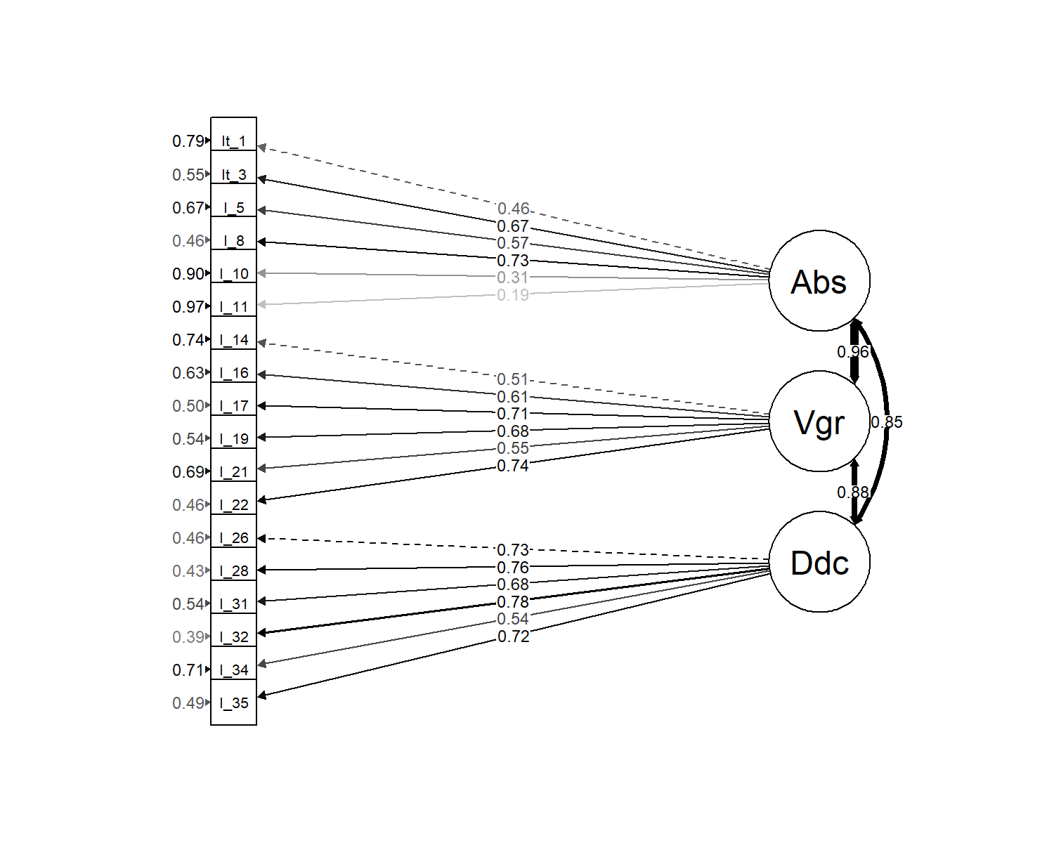*Figure 1.* Substantive factor measurement model

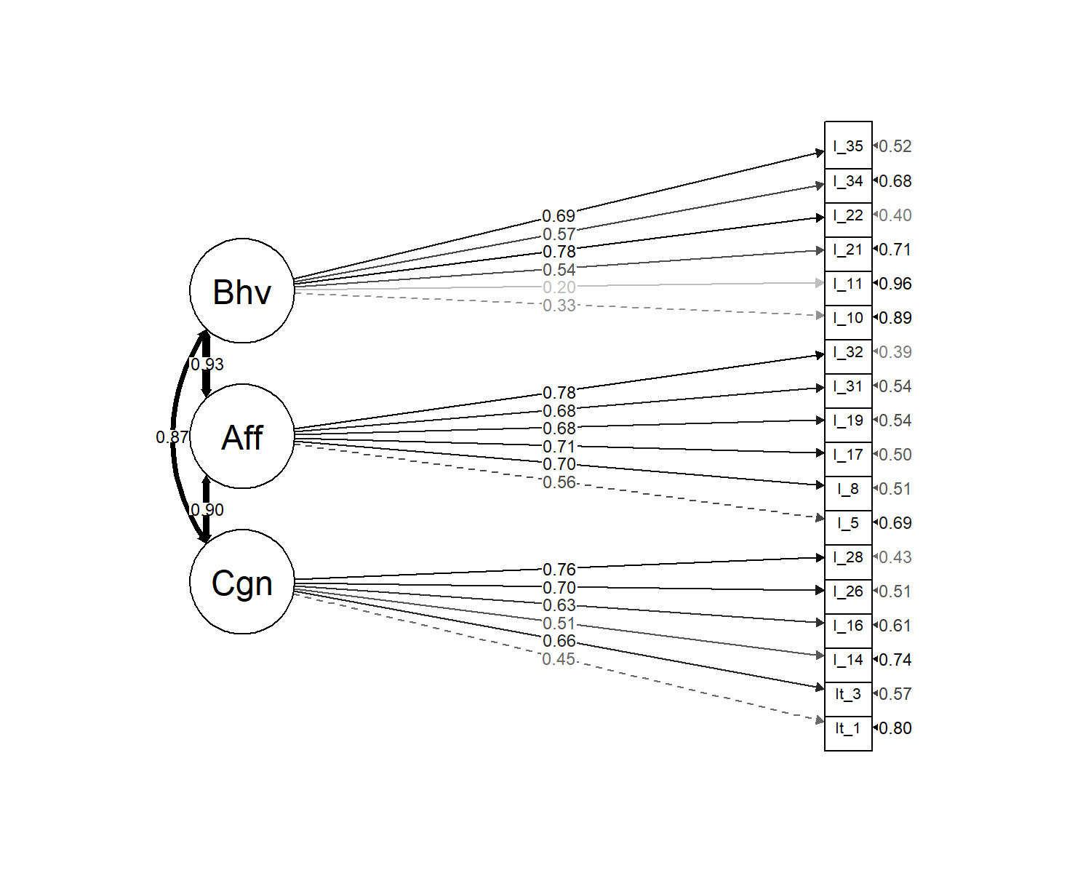*Figure 2.*Attitudinal factor measurement model

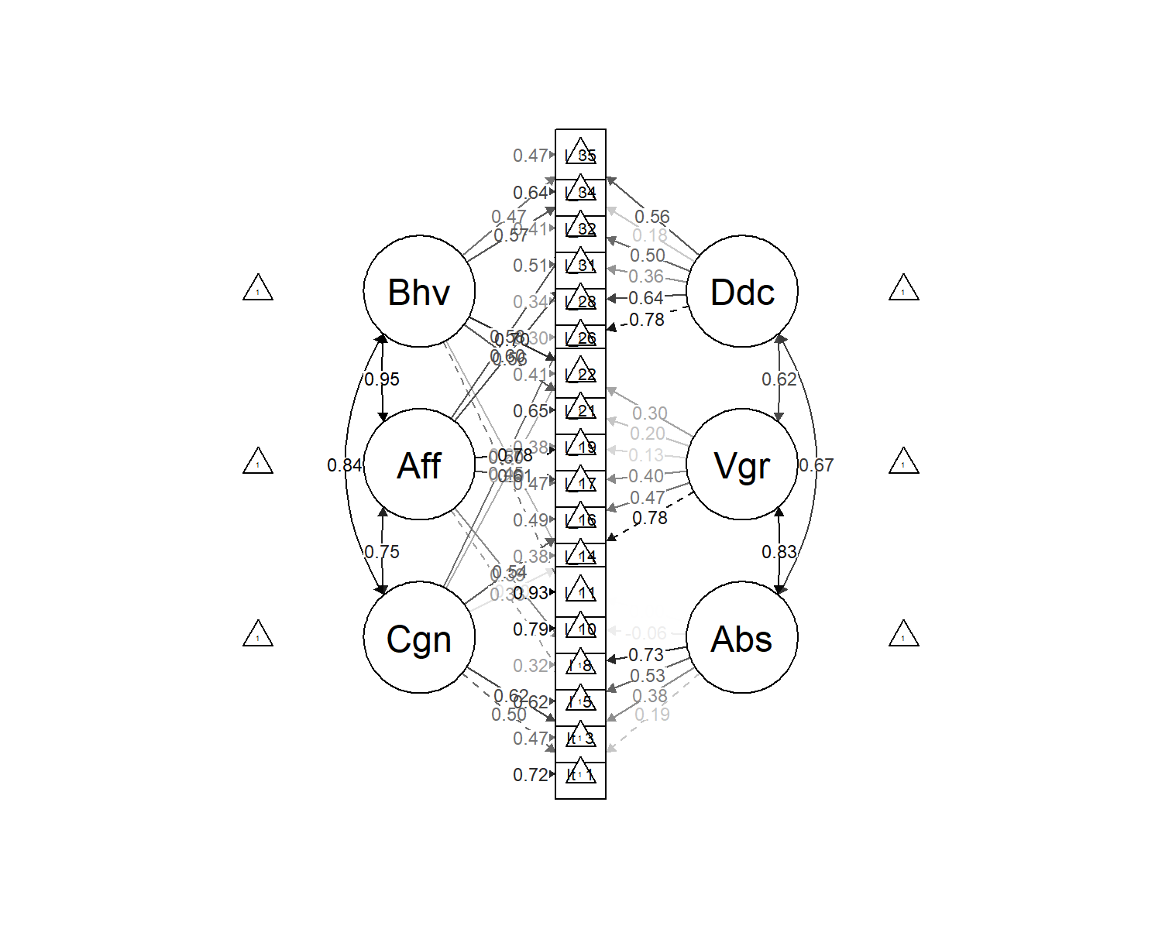*Figure 3*. Bifactor measurement model